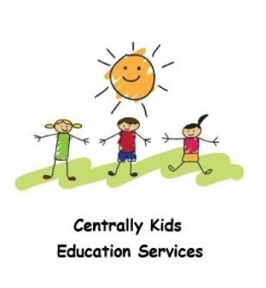
School Readiness Program
Enrolment Form 2024

Student Name: ……………………………………………………………………………………
Date of Birth:…………………….................... Male / Female (circle)
Address:………………………………………………………………………………………………………………………………….
Name of Pre-school / Childcare Centre:………………………………………………………………………...
……………………………………………………………………………………………………….. Age Group:…………………..
NDIS # (if applicable) ………………………………………………………………….

Parent 1 :………………………………………………………………………………………………………………………………..
Phone Number: Home…………………………………………. Mobile……………………………………….
Address:………………………………………………………………………………………………………………………………….
Email:……………………………………………………………………………………………………………………………………….

Parent 2 :……………………………………………………………………………………………………………………………….
Phone Number: Home…………………………………………. Mobile……………………………………….
Address:………………………………………………………………………………………………………………………………….
Email:……………………………………………………………………………………………………………………………………….

Emergency Contact:……………………………………………………………………………………………………………
Phone Number: Home…………………………………………. Mobile……………………………………….
Relationship:………………………………………………………………………………………………………………………….

Health Details: (please provide any relevant information; asthma, anaphylaxis etc)
………………………………………………………………………………………………………………………………………………………………………………………………………………………………………………………………………………………………………………………………………………………………………………………………………………………………………………………………………

Please circle your preferred days/times:

Friday – Greensborough - Beginner
10.00am – 11.00am 3-5 yr olds

I give permission for my child to be photographed for media and social media purposes.

Please tell us any other information we may need to know about your child.
………………………………………………………………………………………………………………………………………………………………………………………………………………………………………………………………………………………………………………………………………………………………………………………………………………………………………………………………………………………………………………..................................................................................................................

Terms and Conditions
Term Payments
Term payments are collected in full at the beginning of each term. Payments can be made by credit card, direct credit or cash. If a session is cancelled, all efforts will be made to re-schedule a session on another day.

Academic Tutoring
Students will experience learning techniques and study skills which are in line with Australian Teaching Standards. No teacher, contractor or employee at Centrally Kids Education Services will be held accountable or financially liable in relation to the rate and depth of a child’s academic progress. Centrally Kids Education Services shall not be held liable for any accident, incident occurring outside the students scheduled sessions or where a student does not comply with teacher instructions or rules of the Program. Where children my need further support or educational assistance, beyond Centrally Kids Education Services we may make recommendations to families and cannot be held liable for these recommendations.

Parent/Guardian Signature:……………………………………………………………………………………………

Date:………………………………

**********************************************************************************************************
Payment by credit card (or email Amanda to request an invoice for direct deposit)
Visa/Mastercard (please circle) *Incurs a 3% surcharge
Name on card:…………………………………………………………
Card No:……………-………………-……………-…………..
Expiry Date:…………………. CVV (3 digits on back of card):…………………

